**Student Management System**

**Stack Holder:**

* Admin: Admin can maintain the entire system.
* Manager: Manager manages students, Batch, Course.
* UML designing member.
* Project implementation members.
* Database handling members.

**Requirements:**

It’s an application for student management system. In a coaching center managing lots of students is very difficult. Also there are many batches which requires managing. With this management system a manager can add students into a batch for this student need to choose course. Student can choose more than one course. Student can paid full or partial amount for the specific course. Manager can update student like name, number, payment status. Manager can publish result. Also a manager can send notice by batch student or specific student.

Admin can view whole database in this system like view student, batch, course, result, payment info.

**Objective of the project:**

* Admission(Student entry)
* Update
* View
* Search

Use Case Diagram:

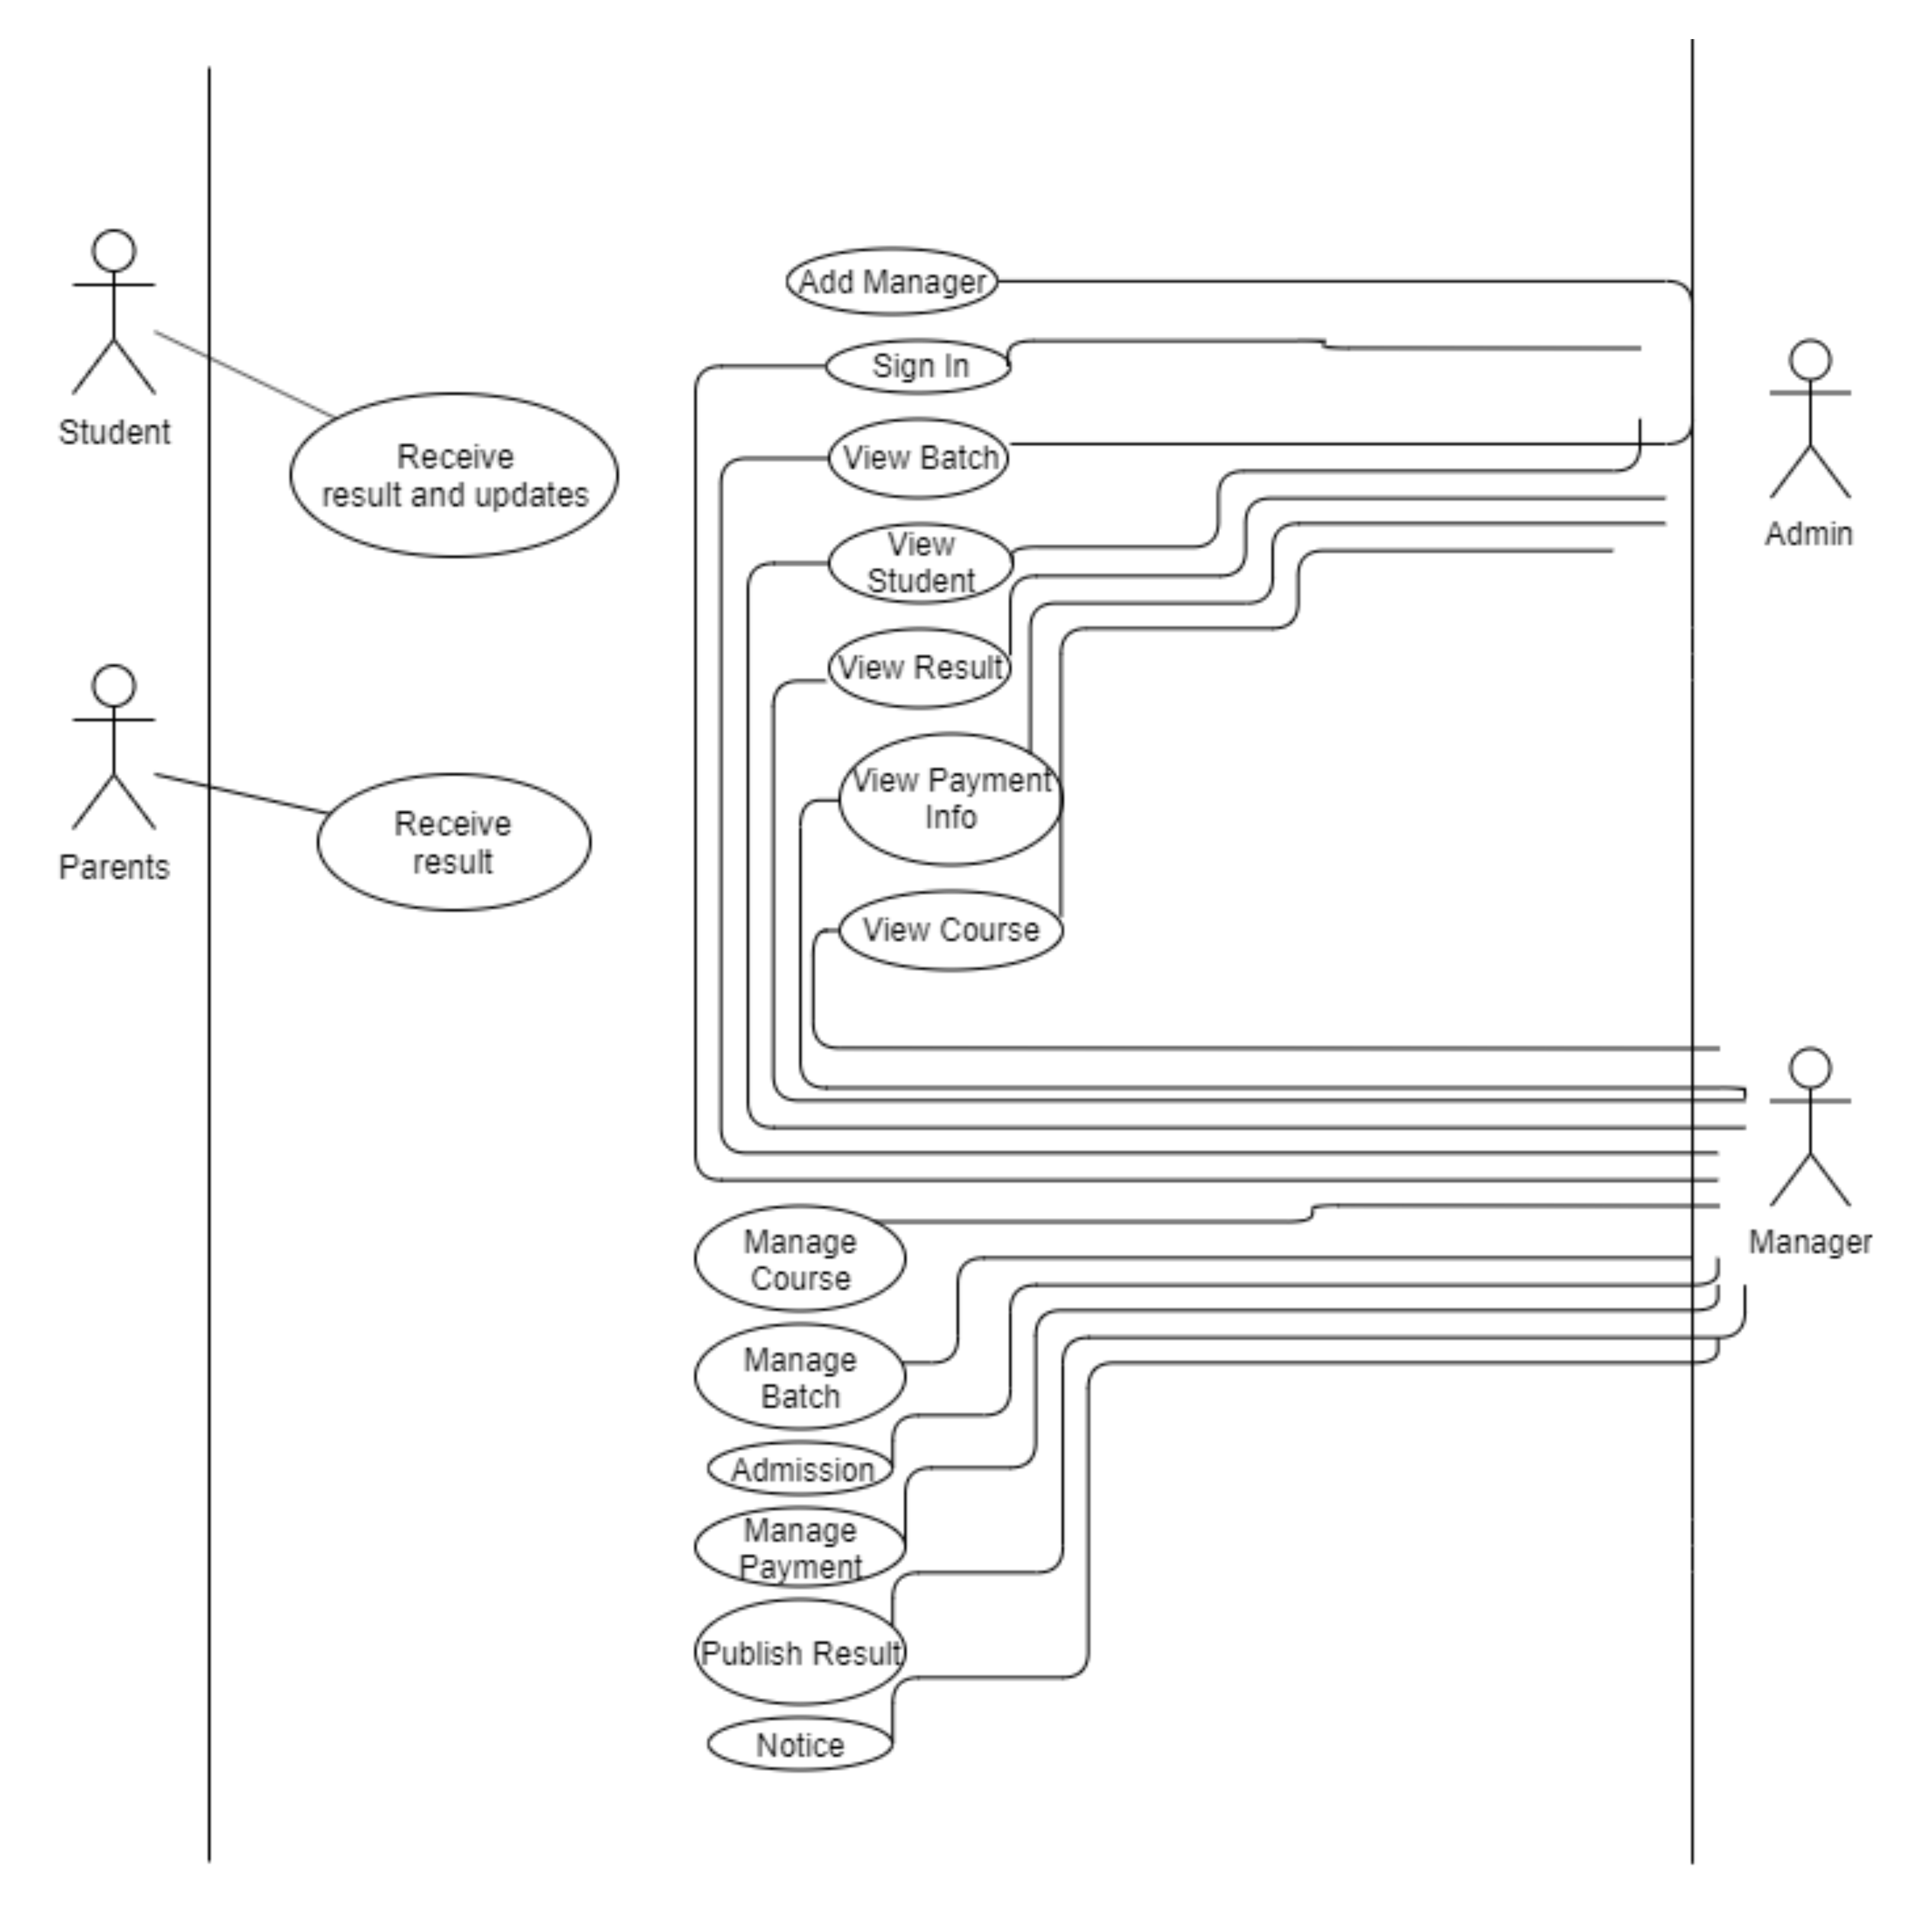

Activity Diagram:

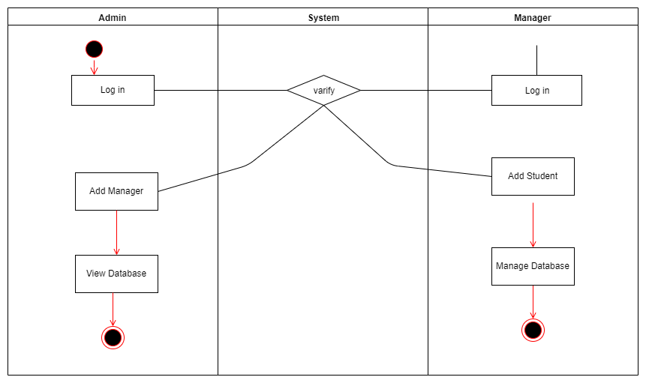

Class Diagram:

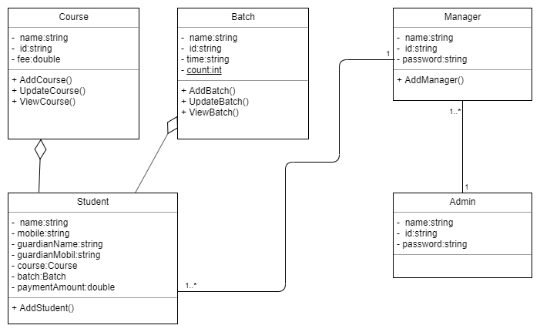

E-R Diagram:

